CAR RENTAL SYSTEM
@CREATIVITY THINK (9483175986/7019689991)

ABSTRACT:
The Car Rental System is a web-based platform designed to simplify the rental process for both customers and administrators. Users can register, browse car listings, filter options based on preferences, make bookings, confirm payments, and review their booking history. Administrators manage cars, bookings, users, and overall analytics through a centralized dashboard. Built with Django and Django Rest Framework for backend operations and React with Axios and Recharts for frontend visualization, the system ensures secure processing, efficient data handling, and engaging user experiences. This project enhances operational productivity and customer satisfaction for car rental businesses..

INTRODUCTION OF THE PROJECT:
Car rental businesses require reliable and efficient software systems to handle large volumes of bookings, maintain vehicle availability, manage users, and process payments. The Car Rental System addresses these requirements by providing an online booking platform with search, filtering, scheduling, and analytics capabilities. Users can conveniently browse available cars, confirm bookings, and track rental history, while administrators maintain listings, monitor bookings, analyze rental trends, and manage user activities. Utilizing Django for backend logic and React for user interaction, the system provides a secure, scalable, and user-friendly environment essential for modern rental businesses and travelers..

PROJECT OBJECTIVES:

• To develop an efficient online platform for booking rental cars
• To enable users to search, filter, and view available cars
• To automate booking, payment confirmation, and rental tracking
• To provide administrators with tools to manage cars, users, and bookings
• To generate visual analytics for business decision-making
• To improve customer convenience through responsive web interfaces
• To maintain secure authentication and data handling throughout the system

PROBLEM OF THE STATEMENT:
Car rental businesses often struggle with managing vehicle inventory, handling overlapping bookings, maintaining manual records, and communicating with customers efficiently. Traditional booking methods may lead to errors, delays, and limited accessibility. Users require an easy-to-navigate platform to browse available cars and confirm bookings without administrative delays. Administrators need a centralized dashboard to manage listings, bookings, and performance analytics. The Car Rental System aims to solve these challenges by providing a real-time, automated, and integrated web platform that enhances accuracy, accessibility, and productivity for both users and administrators..

MOTIVATION OF THE PROJECT:
• Increase efficiency and automation in car rental workflows
• Eliminate booking conflicts and manual record-keeping errors
• Provide a user-friendly online alternative to physical booking counters
• Improve business analytics for rental demand and fleet performance
• Enhance customer experience through faster, smoother interactions

BLOCK DAIGRAM OF PROJECT:

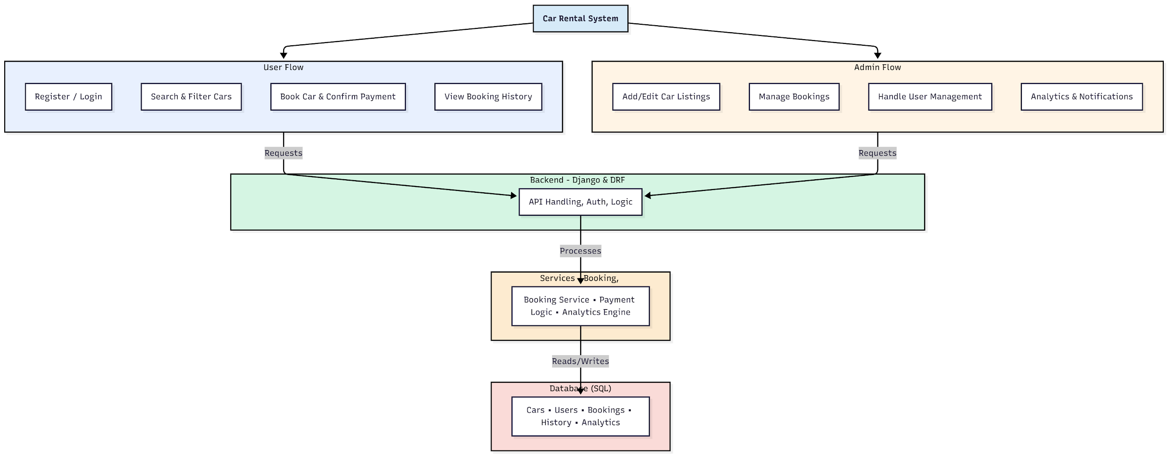

WORKING OF THE PROJECT:
The Car Rental System operates by first allowing users to register or log in and browse car listings. Users then search and filter available vehicles, select preferred options, and proceed with booking and dummy payment confirmation. Their booking history is stored and retrievable at any time. The backend handles authentication, validation, and all booking logic, while integrated services manage analytics, payment confirmation, and data storage. Administrators oversee the platform by adding and editing car listings, monitoring bookings, managing customers, and viewing business analytics. The combined workflow provides a seamless interface for both users and administrators..

SOFTWARE REQUIREMENT:
- Backend:
  - Python 3.x
  - Django
  - Django REST Framework
  - SQLite/PostgreSQL
- Frontend:
  - Node.js and npm
  - React.js
  - Axios
- Development Tools:
  - Visual Studio Code
  - Postman (for testing APIs)
  - Git/GitHub (for version control)
- Server/Deployment (Optional):
  - Gunicorn, Nginx, or Heroku/AWS for hosting

ADVANTAGES OF THE PROJECT:

• Provides real-time car availability and booking
• Reduces manual errors and automates scheduling
• Offers data analytics for business insights
• Enhances user convenience with online booking
• Simplifies car and booking management for admins
• Supports secure authentication and data handling
• Improves fleet utilization and operational efficiency
• Accessible anytime from any device via web interface

APPLICATIONS OF THE PROJECT:
• Car rental agencies
• Travel and tourism companies
• Airport vehicle rental services
• Corporate transport management
• Hotel and resort car rental services
• Local transport operators
• City mobility and weekend rental services
• Startups offering subscription-based car rentals

REFERENCES:

- Django REST Framework Documentation — Django Software Foundation. Django Documentation. Available: https://docs.djangoproject.com/
- Django REST Framework. DRF Documentation. Available: https://www.django-rest-framework.org/
- React. React Official Documentation. Available: https://reactjs.org/docs/getting-started.html
- Redux. Redux Documentation. Available: https://redux.js.org/introduction/getting-started
- PostgreSQL Global Development Group. PostgreSQL Documentation. Available: https://www.postgresql.org/docs/
- MySQL. MySQL Reference Manual. Available: https://dev.mysql.com/doc/
- Git. Git Documentation. Available: https://git-scm.com/doc
- Node.js. Node.js Documentation. Available: https://nodejs.org/en/docs/
- Axios. Axios Documentation. Available: https://axios-http.com/docs/intro
- Socket.io Documentation – https://socket.io/docs/

